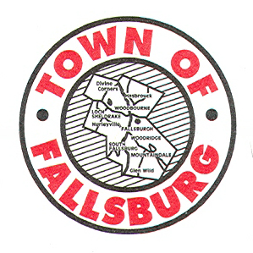

Mollie Messenger
Code Enforcement Officer

TOWN OF FALLSBURG
CODE ENFORCEMENT OFFICE
Member: New York State Building Officials Conference, Inc.

5250 MAIN STREET
SOUTH FALLSBURG
NEW YORK 12779
(845) 434-8811
FAX:(845) 434-5883

___________________________________________________________________________________________________________ June 16, 2015

Evergreen Condominiums
Site Inspection
Billy Jakaitis, Will Illing, Abe Grossman, Ken Ellsworth, Mollie Messenger
To Do:
- Complete signage on island/for parking area
- Take stop sign out on South Branch Rd
- NYSEG ordered light pole
- True level Inner Circle Rd-Who is doing?
- South Branch Rd. makes intersection too high-drainage basin to low-Tom Olley to review and make comment on what to do
- Need utility test results-sample test today
- Epoxy material to fix island in road-send specs to Keystone
- Water pumps station report needed
- Filter sand for storm water basin needed after seeded and hay - Refer to October 13, 2014-Keystone memo-make sure all items completed
- Feather in road by lower catch basin area to allow for snow plow
- Install shoulder on incoming land to the development from 52 to dumpster
- Manholes and pipe replaced by old unit 181 – need report from Tom Olley
- Is there a shoulder detail-what was required? Shoulders not installed
- Install parking area in front of 191-181-too steep Tom Olley to review
- New section for interior road – Was that sent to Keystone from Tom Olley’s office
- Final grade needed, remove piles of dirt
- Pool needs DOH approval and final electrical
- Safety fence to close back property and do not enter signs
- Tom Olley still doing SWPPP inspections-stabilize Phase 2 excavation then they go to month SWPPP inspection
- Compactor needs to be completed
- Fabric not stalled on interior roadways as requested – Tom Olley to Comment
- Notarize a letter regarding completing Inner Circle road and the timeline if Phase 2 does not get built prior to receiving Certificates of Occupancy.
COMMENTS:
- Parking area signs in process of being put up
- Sewer is good-grinder is online
- DOT coming back to ditch rt. 52
- 10 ton roller need for town road, when it gets completed

Email: mmmessenger@fallsburgny.com - gpitula@fallsburgny.com – george.sarvis@fallsburgny.com – denise.ceoclerk@fallsburgny.com

